Design Specification: GROUP 12

Authors: bea16, dpb1, alh32, fik, anp28, srp11, lps1, lot15, thw10
Config Ref: SE_12_DS_01
Date: 06/12/2013
Version: 0.7
Status: Final

Department of Computer Science
Aberystwyth University
Aberystwyth
Ceredigion
SY23 3DB
Copyright © Aberystwyth University 2013

Table of Contents
1 INTRODUCTION 3
1.1 Purpose of this Document 3
1.2 Scope 3
1.3 Objectives 3
2 DECOMPOSITION DESCRIPTION 4
2.1 Programs in system 4
2.1.1 The Android Application. 4
2.1.2 The Server 4
2.1.3 The Website 4
2.2. Significant classes in each program 4
2.2.1 Significant classes for web 4
2.2.2 Significant classes for Android 5
2.3 Modules shared between programs 6
2.4 Mapping from requirements to classes 6
3 DEPENDENCY DESCRIPTION 7
3.1 Component Diagram 7
3.2 Inheritance Relationships 7
4 INTERFACE DESCRIPTION 7
4.1 Web Class Interface 7
4.2 Android Interface Description 11
4.2.1 Tour 11
4.2.2 Location 11
4.2.3 TourUploader 12
4.2.4 HomeActivity 12
4.2.5 Location 12
4.2.6 SettingsActivity 13
4.2.7 TourCreatorActivity 13
5 DETAILED DESIGN 15
5.1 Sequence diagram 15
5.2 Significant algorithms 15
5.2.1 Significant algorithms for Web 15
5.3 Significant data structures 16
5.4 Entity Relationship Diagram 18
5.5 Class Diagram 19
6 REFERENCES 19
APPENDICES 19
Document History 19

1 INTRODUCTION

1.1 Purpose of this Document
This document is here to ensure that the format and content of the information which will be a part of the final design specification document in the the software engineering group project. It will help to make sure that all the major details and functions of the system are described. This will include a description of the programs which are a part of the overall system with a further description of significant classes in each one of them. Component diagram will be shown. The system will be described in detail using a variety of diagrams, algorithms and data structures.

1.2 Scope
This document specifies the standards for writing software design specifications. It describes the necessary layout and content of a design specification. This document will be produced in accordance to the design specification standards document [1] SE.QA.05.A.

The main sections to be covered are:
- Introduction: to include the purpose of the document, scope and objectives.
- Decomposition Description: this section will include a description of the programs in system as well as significant classes in each program. A table showing Specific Requirements and how they are mapped into classes will also be provided.
- Dependency Description: this section will include a component diagram. What is more, inheritance relationships will be described.
- Interface Description: this section will include interface specification for each of the classes.
- Detailed Design: the final section will include a sequence diagram, significant algorithms, significant data structures as well as an entity relationship diagram.
- References: will include references to the external sources used when producing the document.

1.3 Objectives
The main objective is to aid the production of a design specification which is a complete and accurate translation of the client's requirements into a description of the design elements necessary for the implementation phase. These will include the software structure, components, interfaces, and data. In a complete design specification, each requirement must be traceable to one or more design entities. [1]

Objectives are:
  - To describe the programs in system and how they will interact together
  - To show the components and inheritance within the system using component diagrams and inheritance relationships.
  - To specify interfaces for each program.
  - To describe significant algorithms and data structures.

2 DECOMPOSITION DESCRIPTION

2.1 Programs in system
Firstly we decompose the software into 3 main subsystems which are:
- The android application.
- The server.
- The web application.

2.1.1 The Android Application.
The Walk program provides a user interface on a android platform to enable a user to make a walk, way-points, amend walk, way-point, take pictures of way-points and put in information about the way-points
Implements requirements (FR1),(FR2),(FR3),(FR4),(FR5),(FR6),(FR7),(PR1),(PR2) and (DC1) . This program will be form-based so it will comply with (EIR1). The walk program will send the information it generates from the user as described in(FR6)

2.1.2 The Server
The Server provides a storage space for all the information about people's walks so that they can view them online this should implement (FR9),(PR1) and (DC3). The Server will also use a Test Data file which is described in (DC2). The server will save the information it receives inside of a database.

2.1.3 The Website
The Website provides a professional user interface for a person to view a walk online. It also allows a user to search for a specific walk. Details on each walk will then be displayed. Implementing requirements (FR8),(EIR1) and (PR1). The Website will query information from the Server and display it on to the google maps interface so the user can take the tour. The locations within the tour will be shown as pins. The line showing the tour will be drawn based on the way poins recorded during the walk.

2.2. Significant classes in each program

2.2.1 Significant classes for web
As the PHP is procedural each function is treated as a class for the purpose of description.
maps.php Description of classes for the file maps.php.

src="https://maps.googleapis.com/maps/api/js?key=***************************************&sensor=false"> This piece of javascript is part of the google maps API, it gathers my user key and allows access to the functionality of the google map.

var image = 'icon2.png'; This is simply a pointer, but from this we can change the icon presented to us on the google map.

function calcRoute() The calcRoute() function takes the parameters of an origin point and a destination point, from there it will work out the optimal path between the two points and direct the user to follow, drawing the path on the map.

function initialize() The initialize() function is the basis for booting the map. Within contains the while loop that accesses our MySQL database and returns all points for a given path. During this time it will display all points with their appropriate marker location and give the descriptions stored of each and every point.

var request={} This variable takes the origin, destination and method of travel within the route calculation function, and as such outputs the path to take, whilst making sure no redundant information is added to the map such as path start/end markers.

$con Establishes connection to host based on username, password and location.

$res Returns appropriate data from selected database for use with google map.

var LatLng, var ContentString These are variables concerning the retrieval of data from the database, and as such are unique per point. LatLng creates a new marker posted at the given points within our tables, the contentstring updates the information window with the stored point description.

google.maps.event.addListener This creates the information window given at every marker on the map. Creates a listener that waits for a mouse click to open the information window.

var marker = new google.maps.Marker Constructor for the marker, reads the position it should be set at, the animation accompanying it upon opening of the map, the drag mode, the icon and the map it should be assigned to.

google.maps.event.addDomListener(window, 'load', initialize); Creates map upon load of the window, runs the initialize function to ensure all points and paths are plotted upon creation. Opens the map within the specified window space.

2.2.2 Significant classes for Android
Basic descriptions of each significant class within the phone application. A more detailed description provided in the Interface description section.
Tour.java – stores information about each tour. This will include a string for the name, an array of locations, a string for the description, another string for the longer description and a boolean whether it has been uploaded or not.
Image.java – stores data about images for tours.
TourUploader.java – contains an array of the tours. This class will mainly be used for the upload of the tours from the phone to the server so that they can later be viewed on the web interface.
Location.java – contains a String for the name, floats for both latitude and longitude and an image for the location. Furthermore a string for the description and an int for time at which the location has been approached.
Main.java – starts the application.
HomeActivity.java – holds methods that take user input, iit is the home page of the application.
SettingsActivity.java – Allows setting of the app to be configured.
TourCreatorActivity.java – Creates the screen and GUI which takes user input to intern create a tour based on that information.

2.3 Modules shared between programs
The only modules that will be shared between the web application and the android side application is the JSON script that would pass information between the phone and the web storage page via http. The android would pack data into JSON regarding points and this would be sent to the web application to be parsed out and inserted into the relevant tables. The android user may specify as to whether a new path is being generated, and if this is true a new row must be added to the paths table to signify that this path and all points associated are separate entities. Similarly all points made under this new path would be associated on the database side via a pathID foreign key within the rows for each point. JSON must also be able to pack images into a string to be sent, which would allow for easy transmission and ensure that the data can be received and stored. Decoding of such data need only happen upon arrival at the database or on the page as and when requested.

2.4 Mapping from requirements to classes
This table shows each functional requirement that must be met, and which class provides its operation. This will ensure that all requirements are covered, and show the impact that changes to the design may have.

Functional requirement | Class providing requirement
FR1- Startup of software on Android device | Main.java
FR2 - Providing info about the whole walking tour | TourViewerActivity.java
FR3 - Adding locations to the walking tour | TourCreatorActivity.java
FR4 - Adding photos to the walks | LocationCreatorActivity.java
FR5 - Cancelling walks | TourCreatorActivity.java
FR6 - Sending the walk to the server | TourUploaderActivity.java
FR7 - Switching from the WTC | All activity classes
FR8 - Trying out a created walking tour | index.php
FR9 - Saving data on server | TourUploaderActivity.java

3 DEPENDENCY DESCRIPTION

3.1 Component Diagram

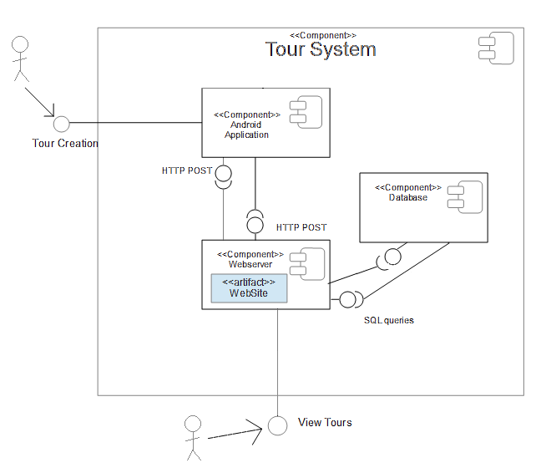
3.2 Inheritance Relationships
Activity classes will inherit from Android API packages.

4 INTERFACE DESCRIPTION

4.1 Web Class Interface
DOCTYPE html>
<html>
/* Using HTML 5 Doctype to support our project. This ensures that the google maps API will be fully supported on the latest web standard, that the phone viewport can be resized and viewed for and there will be no implementation issues concerning any new web tools we may wish to access or incorporate. */ <head>
<meta name="viewport" content="initial-scale=1.0, user-scalable=no" /> <style type="text/css">
html { height: 100% }
body { height: 100%; margin: 0; padding: 0 }
#map-canvas { height: 100% }
</style>
/* A temporary inline CSS for use with this test page. Only contains code necessary for display of the map.*/
<script type="text/javascript" src="https://maps.googleapis.com/maps/api/js?key=***************************************&sensor=false">
</script>
/*Fetches my google maps API key for me to be able to use the google maps
functionality and tools across the site.*/
<script type="text/javascript">
var image = 'icon2.png';
var waypts[];
/*Variable name "image" accesses the location of the saved marker image, can be removed
to revert to default marker or file name can be changed to allocate
new marker should future developments occur.
Variable name "waypts" is an array that contains the lat and long values of points along
the path to be taken for the lines of direction to be drawn for the user. This can only
hold a size of 8 or the path will not draw due to API limits.*/
function calcRoute()
{
var request=
{
origin: new google.maps.LatLng(<?php=$start['lat]?>,<?php=$start['long']?>),
destination: new google.maps.LatLng(<?php=$end['lat]?>,<?php=$end['long']?>),
waypoints: waypts;
travelMode: google.maps.TravelMode.WALKING
};
<?php=$pointpath = mysql_query("SELECT * FROM pathlines WHERE `pathID` = $_POST["path"] && `pointID` = $_POST["points"];
while($b=mysql_fetch_array($pointpath)
{>?
for(i=0;i<8;i++)
{
waypts.push[{<?php=$b['lat]?>,<?php=$b['long']?>}];
}
<?php=}?>
directionsService.route(request, function(response, status)
{
if (status == google.maps.DirectionsStatus.OK)
{
directionsDisplay.setDirections(response);
directionsDisplay.setOptions({suppressMarkers: true});
}
});
/*Calculates routes between two points. Uses an origin point to find start of path, and destination point to use as end of path. Travel mode dictates what type of route and paths are allowed. Walking indicates any available path over land, driving may only use roads however. Walking is appropriate for prototype path. The tool behind this to be used is google map's very own "polyline" type, which will run through all of the points specified between two points selected. Suppressed markers is a tool used to prevent the appearance of additional markers dictating start/end points of a path and cluttering the GUI.*/
}
function initialize()
{
var mapOptions = {center: new google.maps.LatLng(52.413571,-4.073489), zoom: 14};
var map = new google.maps.Map(document.getElementById("map-canvas"),mapOptions);
var infowindow = new google.maps.InfoWindow();
window.directionsService = new google.maps.DirectionsService();
window.directionsDisplay = new google.maps.DirectionsRenderer();
directionsDisplay.setMap(map);
/*Initializes map for later, starts by creating variables and generates paths within the window. Adds path to the map and sets the position at center when the map is first displayed. Also sets the rate of zoom so the entirety of the path is covered.*/
<?php
$con = mysql_connect("localhost","root","");
if (!$con)
{
die('Could not connect: ' . mysql_error());
}
mysql_select_db("pathdb", $con);
$res = mysql_query("SELECT * FROM points");
while($a = mysql_fetch_array($res))
{
?>
/*Creates a connection to my local hosting server, selects database to use and then chooses the data from which tables I am currently interested in. Enters a while loop to assign each marker and create it as such.*/
var LatLng = new google.maps.LatLng(<?=$a['lat']?>,<?=$a['long']?>);
var ContentString = "<b><?=$a['shortDesc']?></b></br><?=$a['longDesc']?>";
var marker = new google.maps.Marker(
{
map:map,
draggable:false,
animation: google.maps.Animation.DROP,
position: LatLng,
icon: image
});
marker.content = ContentString;
google.maps.event.addListener(marker, 'click', function(){
infowindow.setContent(this.content);
infowindow.open(this.getMap(),this);
});
/*Uses value (Lat,Long) to create point marker on map, assigns variable "ContentString" which creates a bolded up title as the short description, followed by a new line for the long description per point. Marker is generated for our map, with drag disabled, a drop animation on generation, marker appears at the given (Lat,Long) position and marker at point is assigned to image variable given earlier. Listener sets up the information to go into our information window and sets the function to open the window upon the click of the marker happening.*/
<?php
}
?>
calcRoute();
/*Closes the while loop and calls the path finding function between points.*/
}
google.maps.event.addDomListener(window, 'load', initialize);
/*Upon loading of page, the map is generated with it's appropriate window space, and the function initialize is called and therein all paths are brought up and all points are created.*/
</script>
</head>
<body>
<div id="map-canvas"/>
</body>
/*Creates the map on the website, closes all HTML concerned with page.*/ </html>

4.2 Android Interface Description

4.2.1 Tour
public class Tour {
private String name;
private Location[] locations;
private String description;
private String longDescription;
private boolean uploaded;
/*
* Return the JSON representation of this object.
*/
public String toJson() {
return null;
}
/*
* Add a location to the end of the list of locations.
*/
public void addLocation(Location location) {
}
}

4.2.2 Location
public class Location {
private String name;
private float latitude;
private float longitude;
private Image image;
private String description;
private int time;
/*
* Return the JSON representation of this object.
*/
public String toJson() {
return null;
}
}

4.2.3 TourUploader
public class TourUploader {
private Tour[] tours;
/*
* Upload the tours to the server.
* Return true if the upload was successful.
*/
public boolean upload() {
return false;
}
}

4.2.4 HomeActivity
public class HomeActivity extends Activity {
/*
* Create the activity.
*/
protected void onCreate(Bundle savedInstanceState) {
}
}

4.2.5 Location
public class Location {
private String name;
private float latitude;
private float longitude;
private Image image;
private String description;
private int time;
/*
* Return the JSON representation of this object.
*/
public String toJson() {
return null;
}
}

4.2.6 SettingsActivity
public class SettingsActivity extends Activity {
private TourSettings settings;
/*
* Create the activity.
*/
protected void onCreate(Bundle savedInstanceState) {
}
}

4.2.7 TourCreatorActivity
public class TourCreatorActivity extends Activity {
private Tour tour;
private LocationClient location;
private Location currentLocation;
/*
* Reads the lat and long from the GPS and saves it in the current
* location.
*/
private void recordCoordinates() {
}
/*
* Reads a name from the user and adds it to the tour.
*/
private void recordName() {
}
/*
* Reads a description from the user and adds it to the tour.
*/
private void recordDescription() {
}
/*
* Read long description and add to the tour.
*/
private void recordLongDescription() {
}
/*
* Take image from the camera app and adds it to the current location.
*/
private void recordImage() {
}
/*
* Reads a description from the user and adds it to the current location.
*/
private void recordLocationDescription() {
}
/*
* Create the activity.
*/
protected void onCreate(Bundle savedInstanceState) {
}
}

5 DETAILED DESIGN

5.1 Sequence diagram

Tour
TourUploader
Location
Load App
Get location
Start walk
Record locations
Store route locally
Upload walk via to database via WIFI

5.2 Significant algorithms

5.2.1 Significant algorithms for Web
The first significant algorithm to be concerned at for our backend of the map would be that of the marker positions, marker positions are projected using stored lat/long positions for points based on the path selected by the user.

$res = mysql_query("SELECT * FROM points where `pathID` = $path"); while($a = mysql_fetch_array($res)) {var marker = new google.maps.Marker}

This snippet of code outlines the selection process for markers on the map. At the top the markers are selected based upon the path they belong to, and then for every marker meeting this criteria, it is based onto the map based on it’s latitude/longitude values along with the description of the point stored within the information window.

var flightPath = new google.maps.Polyline({path: flightPlanCoordinates,strokeColor: '#FF0000',strokeOpacity: 1.0,strokeWeight: 2});

The google maps API comes packed with a tool called “Polyline”, this will allow the web page to sketch it’s own paths around the map, in which the path of the Polyline will be drawn from an array of lat/long values under the “path” method of the Polyline class.

The methods for obtaining the array to give to the polyline involves a for loop that counts from 0 to 7 (8 values) and for each loop, will push the new lat/long value to the array.

Present on the page for the map will now be buttons that will cast POST calls to the same header page, altering the values used and will show different routes between points and different paths as and when called.

This is however the extent of the significant algorithms to be used in the maps functionality.

5.3 Significant data structures
Our significant data structure used is a schema made in Json.

{
"type": "object",
"properies": {
"name": {
"type": "string",
"description": "The name of the tour"
},
"short-description": {
"type": "string",
"description": "The short description of the tour"
}
"long-description": {
"type": "string"
"description": "The longer description of the tour"
},
"locations": {
"type": "array",
"description": "An array of all the locations in the tour",
"items": {
"type": "object",
"description": "A single location",
"properies": {
"name": {
"type": "string",
"description": "The name of the location to be displayed to the user"
},
"latitude": {
"type": "number",
"description": "Latitude in degrees"
},
"longitude": {
"type": "number",
"description": "Longitude in degrees"
},
"time": {
"type" "number",
"description": "Unix timestamp of the time the location was recorded"
},
"image": {
"type": "string",
"description": "Base64 encoded JPEG image"
}
},
"required": [
"name",
"latitude",
"longitude",
"time",
"image"
]
}
}
},
"required": ["name", "short-description", "locations"]
}

This is the schema that we will be using. Essentially, Tours that we create in the android application are made in Java, which is converted into a Json post. This is done so the application must adhere to provide the correct data each time it sends information to the database for storage.

If the application tries to send a Post to the database, and the data sent does not conform to the Json schema, it will fail to validate, and an error will be displayed.
The Json Post can be interpreted in PHP due to the fact that it is language-independent. This means that we do not have to make any difficult conversions to the data that is sent back and forth between the Database and the Java application.

json_decode() can be used to convert Json strings into PHP variables very easily, and this can then be stored in the database without much fuss. The function json_encode() can then be used to send information back to the Handheld device.

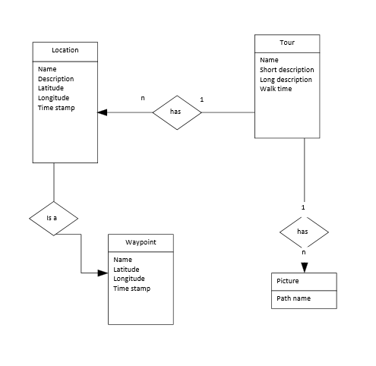
5.4 Entity Relationship Diagram

5.5 Class Diagram

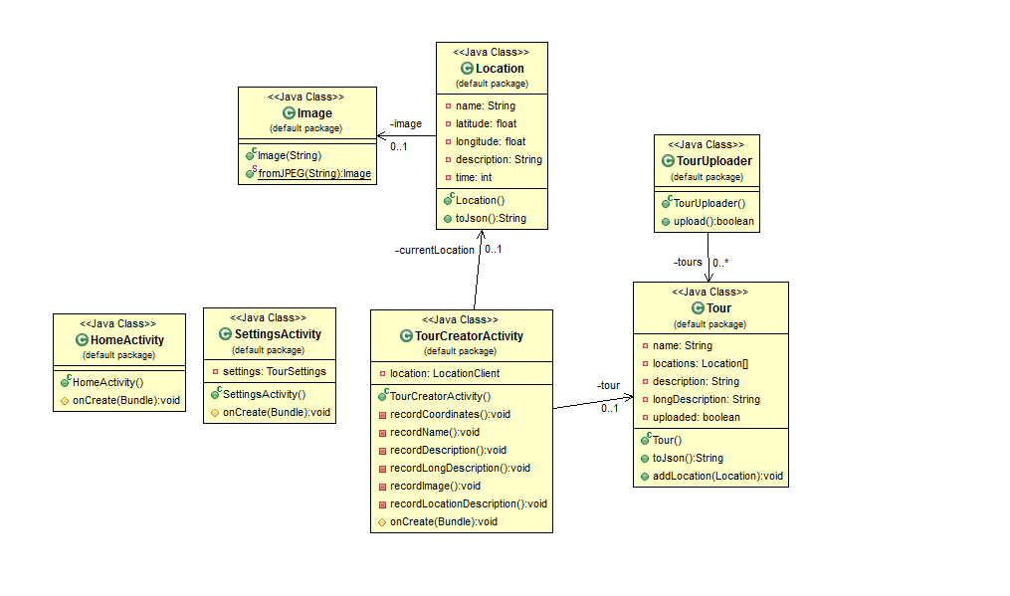
6 REFERENCES
[1] Software Engineering Group Projects. Design Specification Standards. C. J. Price, N.W.Hardy and B.P.Tiddeman. SE.QA.05A. 1.7. Release.

APPENDICES

Document History

Version | CCF No. | Date | Changes made to the document | Changed by
0.1 | N/A | 25/11/13 | Initial creation. | LPS1
0.2 | SE_12_DS_01 | 01/12/13 | Introduction added | LPS1
0.3 | SE_12_DS_01 | 01/12/13 | Mapping requirements to classes section added | LPS1
0.4 | SE_12_DS_01 | 04/12/13 | Added significant classes for web, programs in system and decomposition description | LPS1
0.5 | SE_12_DS_01 | 04/12/13 | Added Significant classes for Android | LPS1
0.6 | SE_12_DS_01 | 05/12/13 | Interface descriptions for Android added, squence diagram added, significant data structures added, added algorithms for web. | LPS1
0.7 | SE_12_DS_01 | 06/12/13 | Document revised & vetted. | LPS1

